COUNTY OF NORTH YORKSHIRE EDUCATION DEPARTMENT

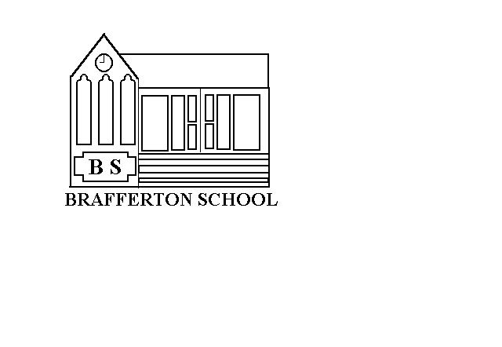
St. Peter's Brafferton C.E. (V.A.) School,
Helperby.
York. YO61 2PA

Mrs Jude Williams
Head Teacher
Tel. (01423)360250
e-mail: admin@st-peters-brafferton.n-yorks.sch.uk.

Dear Parents

Emergency Contacts/Telephone Numbers
In order to keep our records up to date, please will you complete the slip below and return it to School. You will appreciate that it is important for us to have an up to date list of contact details for your child in case of illness or other emergency.

Please give as many contacts as you feel are necessary.

Yours sincerely

Mrs Jude Williams
Headteacher

Name of Child

Name of Contact | Telephone/Mobile No
6.

