COUNTY OF NORTH YORKSHIRE EDUCATION DEPARTMENT

St. Peter's CE (VA) Primary School,
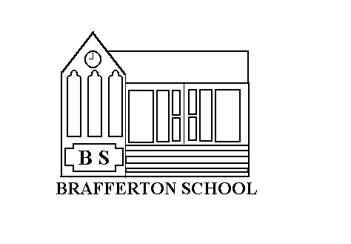

Helperby
York
YO61 2PA

Head Teacher Mrs Williams
Tel. (01423) 360250
Email: admin@st-peters-brafferton.n-yorks.sch.uk

PUPIL RECORD

Child's full name
Date of birth
Address & Post code
Telephone no. home
Email address
Date enrolled
Religion
Nationality
Country of Birth
Mother's name
Occupation
Work Phone No.
Father's name
Occupation
Work phone No
Doctor's name
Surgery Address
Telephone no
Previous serious illnesses
Allergies
Special disabilities
Other information (including child's position in family e.g. G B shows boy with an older sister)
Schools previously attended

