COUNTY OF NORTH YORKSHIRE EDUCATION DEPARTMENT

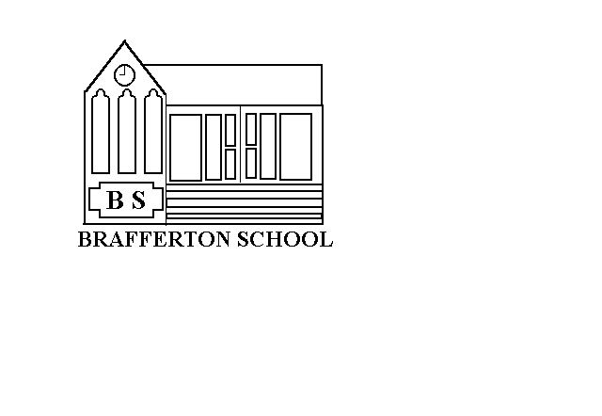

St. Peter's Brafferton C.E. (V.A.) School,
Helperby.
York.
YO61 2PA

Head Teacher Mrs Jude Williams
Tel. (01423)360250

Email: admin@st-peters-brafferton.n-yorks.sch.uk

SWIMMING CONSENT FORM

I give my permission for my child to travel by coach to Thirsk each week for swimming lessons with the school staff and helpers during the relevant school terms.

Name of Child
Signature of parent/guardian
Name

Date

